**Quantum Computing Companies Stock Prices Analysis and Forecasting Web Application Project Part 4**

Pushkar D, Sharanbasav S, Vighnesh K

**Tools:**

We are using Fire store Database (A database provided by Google’s Firebase) on the server side. The data is stored in a NoSQL database format. The data has a unique ID, which is derived from two attribute values: Ticker and Date (in MMDDYYYY format). In Fire store database, all the rows are stored as documents, so each document has its own document

In React, the data is managed by state and user interactions. It is then sent to the Firebase server using the database credentials and stored as a document or if it’s a CRUD operation like a Read request, delete request, Update request, the data is managed in similar manner. For generating dashboards, the data is pulled from the Firestore Database using the Ticker value which user will have to give as an input.

Based on the ticker value, the dashboard is generated for that specific stock.

There is a database configuration file in the project repository which takes care of all the credentials: apiKey, authDomain, projectId, storageBucket, messagingSenderId, appId, measurementId. These credentiala are used to make a connection to the Firestore database. There are specifically designed functions like, addDoc(), getDocs(), updateDoc(), deleteDoc() for accessing data from the database. We input the database credentials, document ID or the value from the document that we want to manage.

We are using React JS in the front end. React is a JavaScript library built for developing web applications. For designing and styling the layout, we are using CSS. It is a component-based library for making interactive and encapsulated UI components that manage their own state. All the components are stateful, meaning when the state changes, it re-invokes the render () and the markup is updated likewise.

The web application is deployed on the firebase server. It creates a build file in the project directory which can be used to deploy and updated the application once it’s deployed. It requires for login to the firebase server and then accordingly the project is deployed by the connecting to the project on the firebase console (server-side)

#### **Web App Layout**

Initial Layout of first page

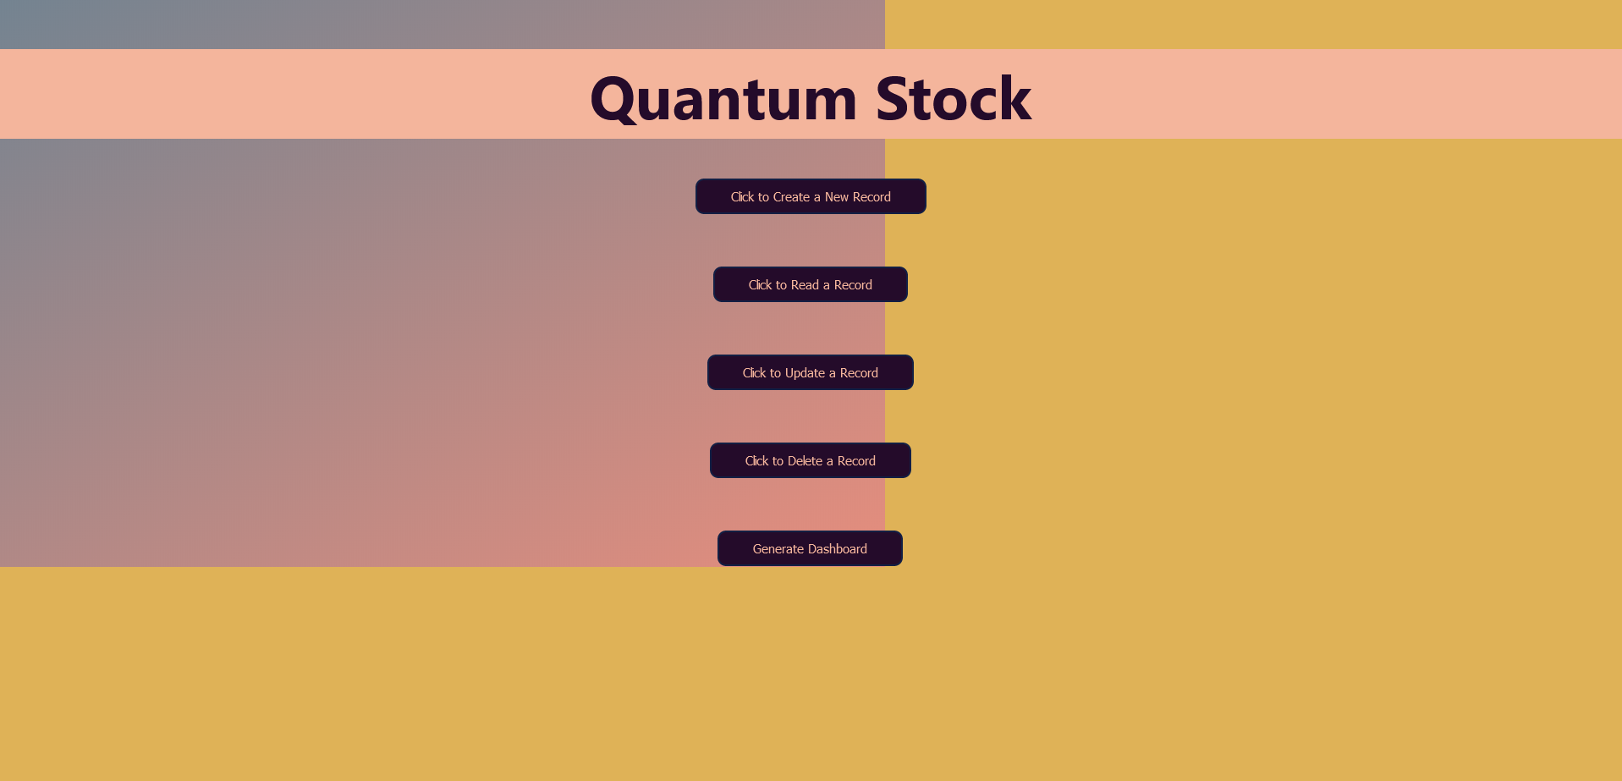

When the user loads the website the first page itself is the menu page where he has the option to perform Create a new record, delete a new record, Update the new record, and Delete record. There is also an option for generating a dashboard where the user can see the trends for ticker.

#### **Web App Functionalities**

1. Creating a new record

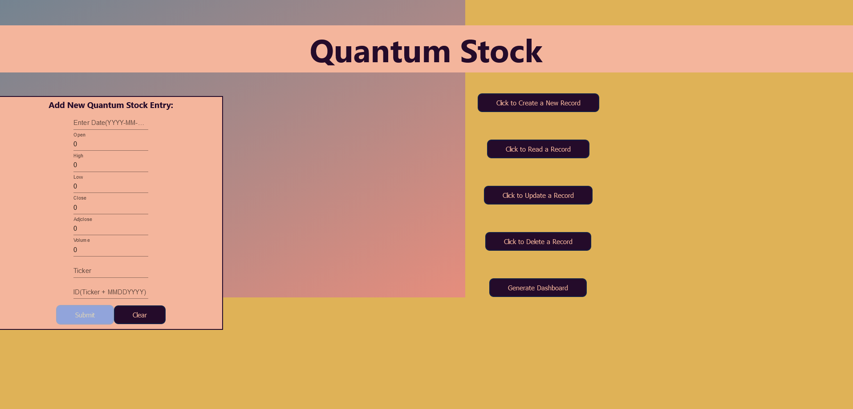

The above image shows the option of creating a new record where user can add into database for particular ticker record

1. Read record

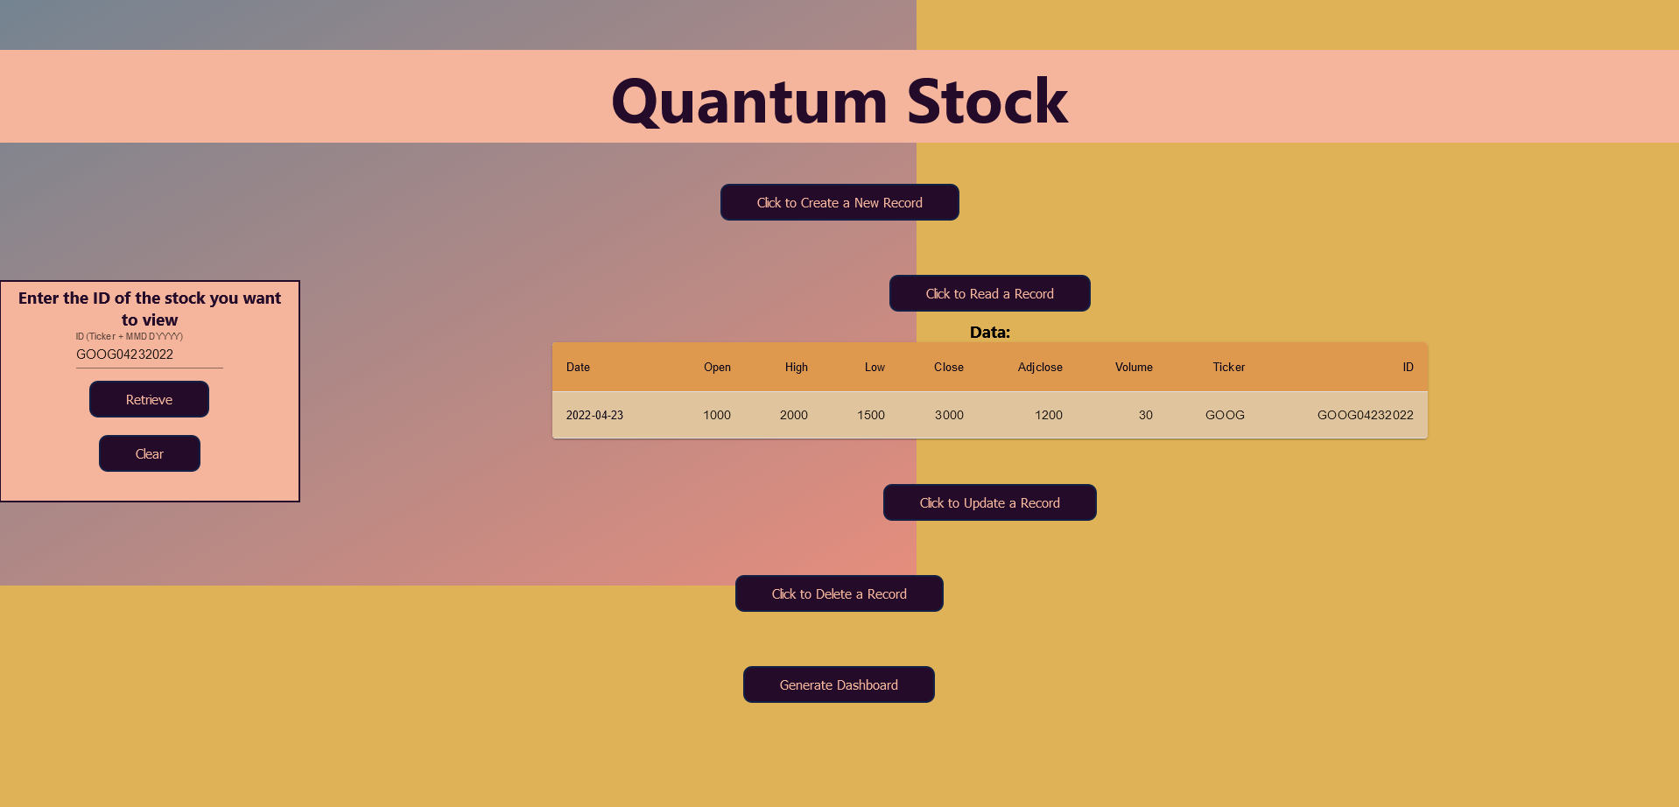

The user gives an input of ticker ID which is in format ticker+MMDDYYY which gives unique ID for all tickers and easy to fetch records for the ticker record at a given date

1. Update a record

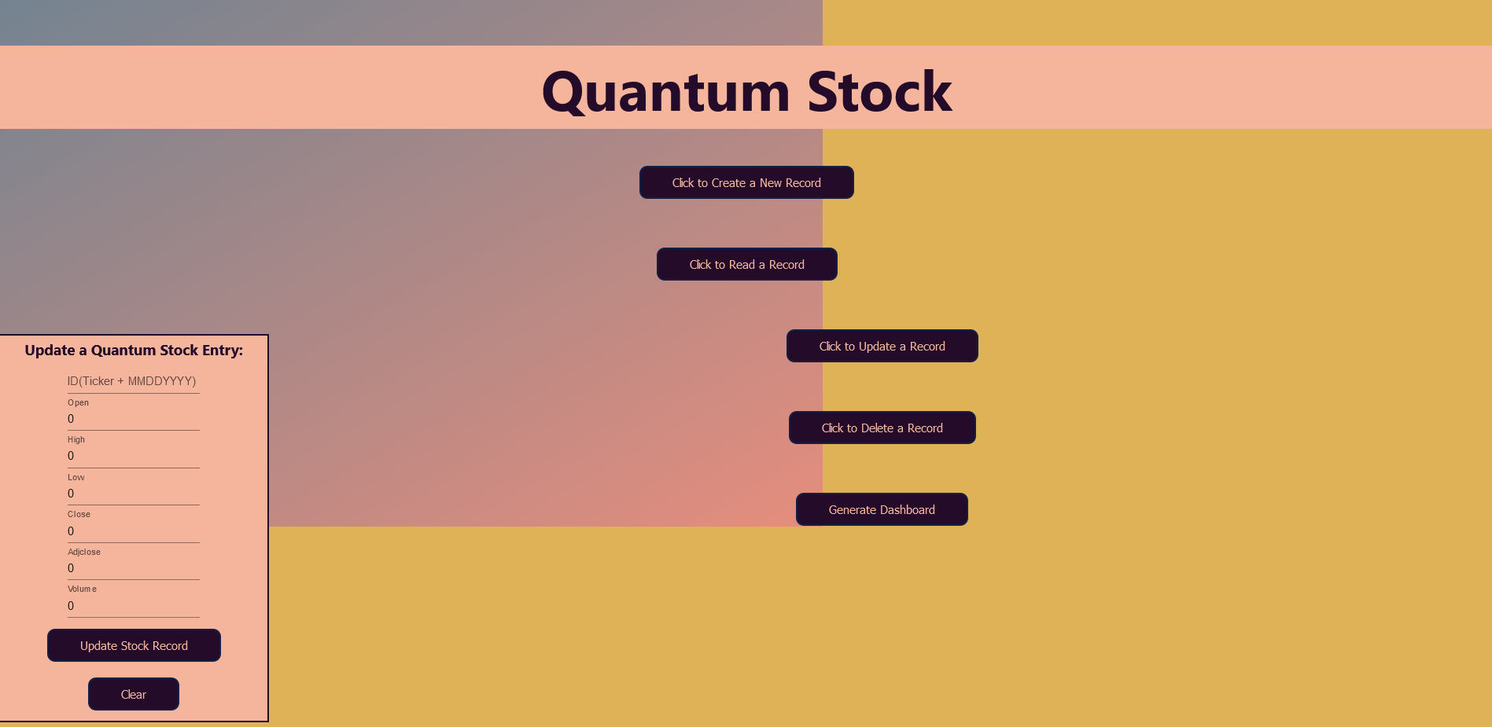

The user gives an input of tickerID for which the user wants to update the record.

1. Delete Record

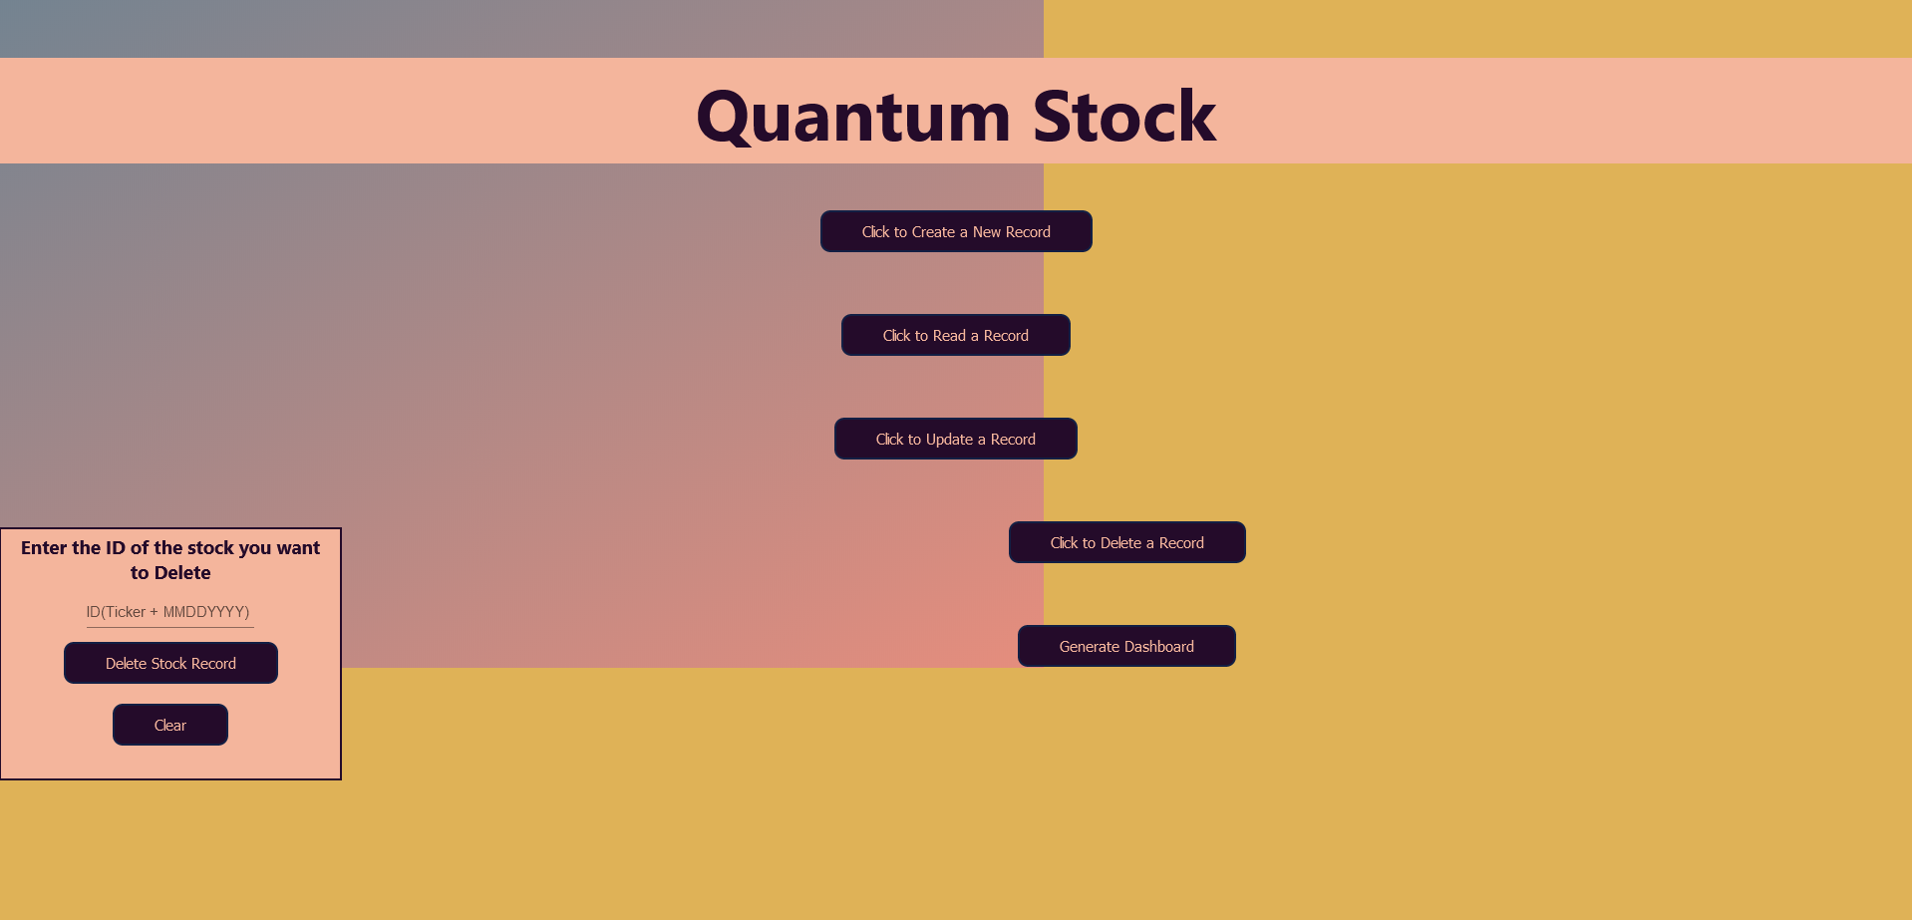

Similar to read record in delete records the user gives an input of TickerID for the particular ticker date the user wants to delete the record for.

1. Generate Dashboard

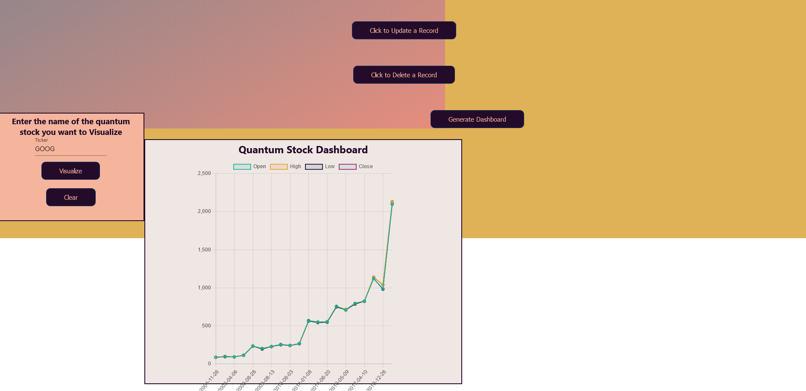

Generate dashboard gives user an option to view the graphical representation of the ticker to get an idea of overall trend and performance of the ticker.

The color scheme used for creating front end are rgb(223, 178, 87), rgb(255, 255, 255), rgb(244, 181, 156), rgb(36, 11, 42). There are no tabs used in this project. The user will be able to see the output on the same page as shown in the screenshot above. For this project we require only single page to perform all the required functionalities.

**Data:**

In this project we are using Quantum Stock dataset where we have 9 attributes where ID is the primary key which describes the uniqueness. Apart from that we have Date which is varchar and shouldn’t be NULL. As the values of stock are recorded on daily basis Date shouldn’t be NULL. If on particular day the prices of stocks are not recorded then the value is either set to ‘NA’ or ‘-‘, which is indeed a particular record for that date. In stock trading, the high and low refer to the maximum and minimum prices in each time period. Open and close are the prices at which a stock began and ended trading in the same period. Volume is the total amount of trading activity. Adjusted values factor in corporate actions such as dividends, stock splits, and new share issuance. Financial periodicals and websites often include a stock's "high" and "low" price. The high is the highest price at which a stock traded during a period. The low is the lowest price of the period. A stock's high and low points for the day are often called it's intraday high and low. As these represents a number value hence we assigned open, high, low, close, adjclose, volume as numeric value. A stock symbol is a unique series of letters assigned to a security for trading purposes. Stocks listed on the New York Stock Exchange (NYSE) can have four or fewer letters. Nasdaq-listed securities can have up to five characters. Symbols are just a shorthand way of describing a company's stock, so there is no significant difference between those that have three letters and those that have four or five. Stock symbols are also known as ticker symbols. As these values represent letters or symbols, we used VARHCAR as data type.

**Project Links:**

**GitHub URL:**  <https://github.iu.edu/vkolhatk/quantum-stock>

**Web URL:** <https://quantum-stock-63803.firebaseapp.com/>

**Teamwork:**

Webapp architecture: Vighnesh, Sharanbsav

Webapp Frontend and Design: Pushkar, Vighnesh,

Database and connections: Sharanbasav, Pushkar,

Documentation: All team members contributed.

Pushkar: 34 percent

Vighnesh: 34 percent

Sharanbasav: 32 percent